Started with module 3:

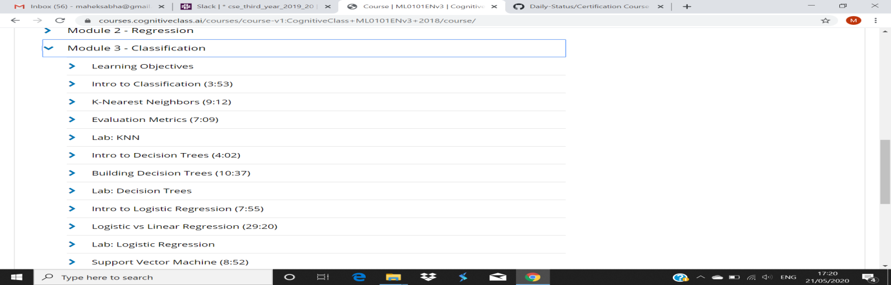

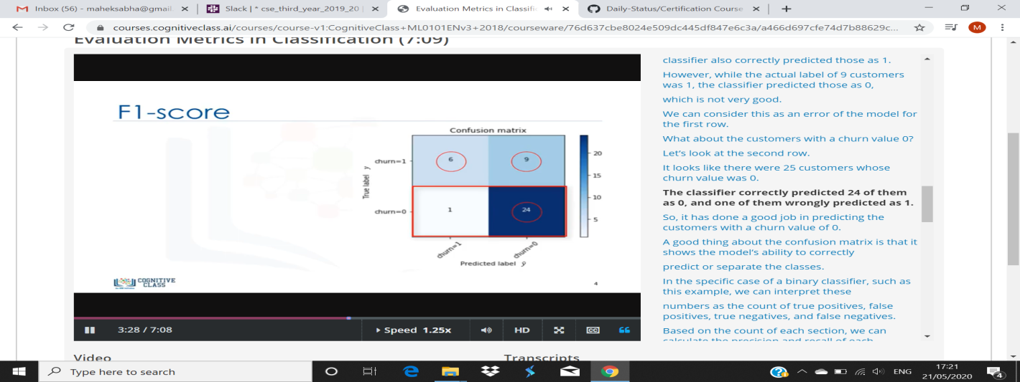

We can use **classification** performance **metrics** such as Log-Loss, Accuracy, AUC(Area under Curve) etc. Another example of **metric** for **evaluation** of machine learning algorithms is precision, recall, which can be used for sorting algorithms primarily used by search engines.